**AWS assignment**

Instance created

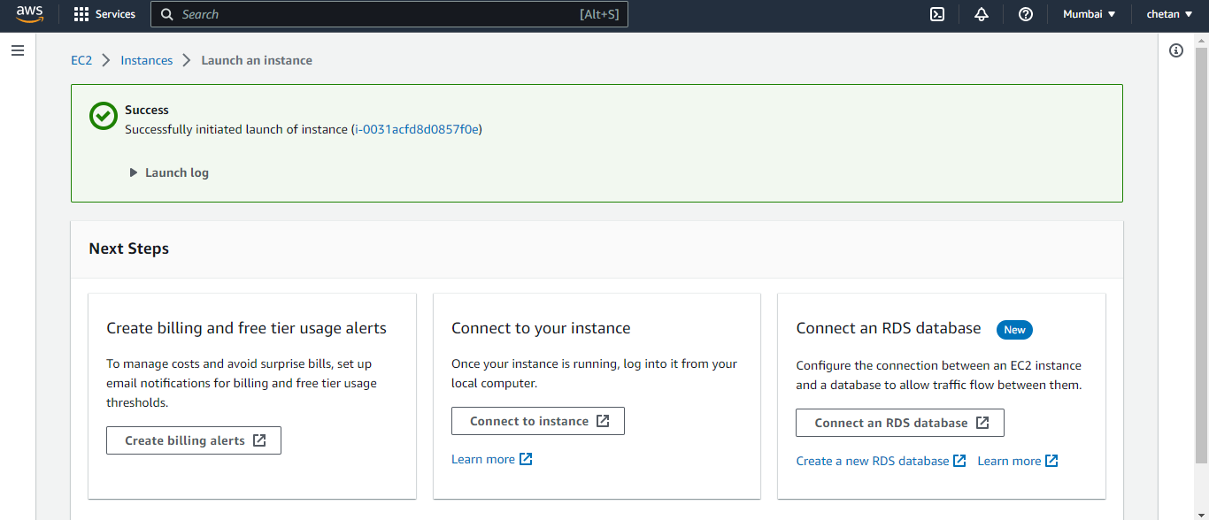

Connecting instance

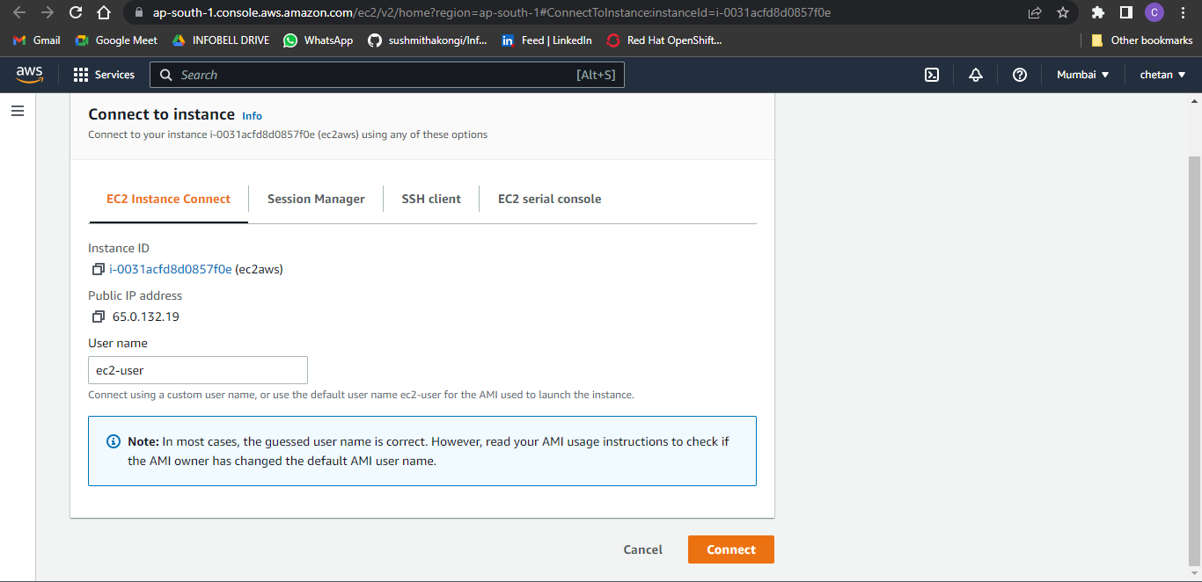

Linux cmd opened

Filezilla for transfer file from local to ec2

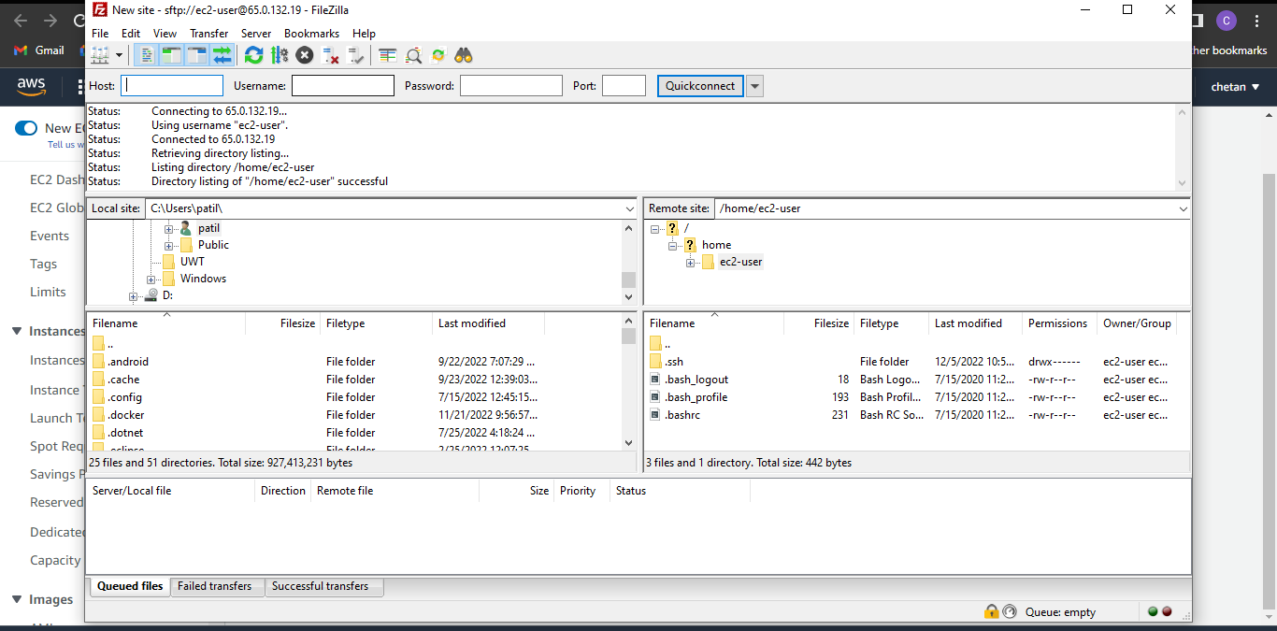

Running instance

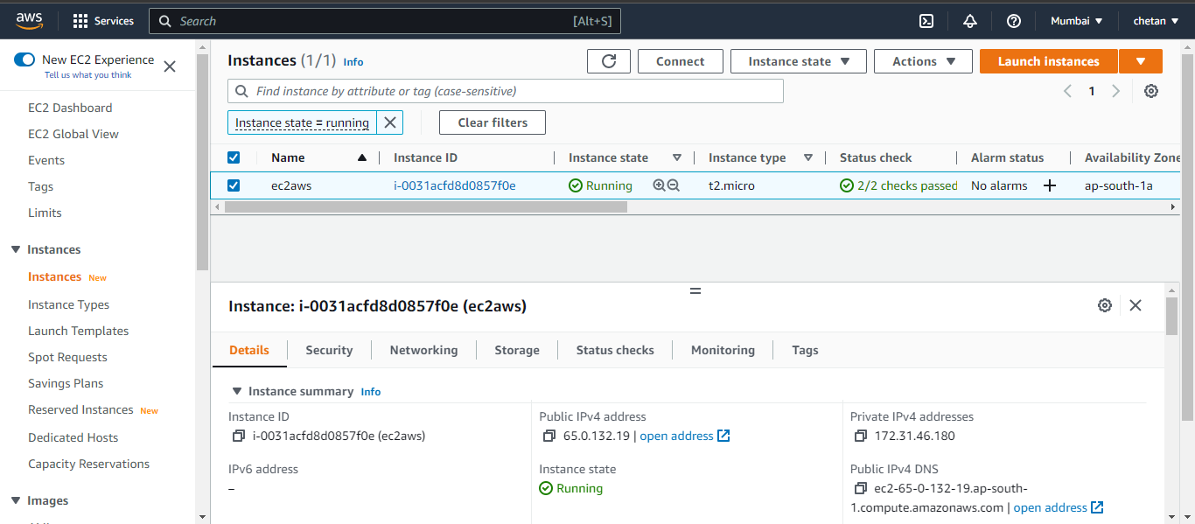

Command prompt in ec2

Output of python

